CSV Module– General information

This doc contains some general information about the python built in CSV module.

This is how we initialize a .JSON file with CSV module:

*import* csv  
file = 'names.csv'  
  
*with* open(file) *as* f:  
 csv_reader = csv.reader(f)

[next(csv_reader) *for* x *in* range (0,9)] # If you want to skip the next 9 lines  
 # If we print csv_reader it will give us an object type

*for* line *in* csv_reader:  
 print(line)

The output should look something like this

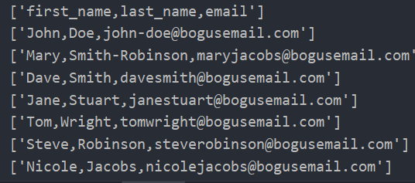

To print each column in this csv file we can do the following:

*with* open(file) *as* f:  
 csv_reader = csv.reader(f)  
  
 *for* line *in* csv_reader:  
 print(line[2])